Asia-China-Coin-Flat Handled Spade Money-Type 1-Arched Foot Spades

State of Liang (Wei) 425-344 BCE, Bronze Flat Handled Arched Foot Spade, 400-300 BCE.

This type has an arched crotch, often like a inverted U. The shoulders can be rounded or angu­lar. Denominations of half, one, or two jin are normally specified. They are associated with the State of , Liang (also known as Wei) which flourished between 425 and 344 BCE, and the State of Han

Flat Handled Spades have lost the hollow handle of the early spades. They nearly all have dis­tinct legs， suggesting that their pattern was influenced by the pointed shoulder Hollow Handled Spades， but had been further stylized for easy handling. They are generally smaller， and some­times have denominations specified in their inscriptions as well as place names. This， together with such little evidence as can be gleaned from the dates of the establishment of some of the mint towns， show that they were a later development. Archaeological evidence dates them to the Warring States period (475-221 BC). Arched Foot spades have an alloy consisting of about 80% copper; for other types the copper content varies between 40% and 70%.

This type has an arched crotch, often like a inverted U. The shoulders can be rounded or angu­lar. Denominations of half, one, or two jin are normally specified. They are associated with the State of Liang (also known as Wei) which flourished between 425 and 344 BCE， and the State of Han.

Example 1. Ān Yì bàn [half] jīn, 安邑半釿, Round Shoulder, Inscription inverted

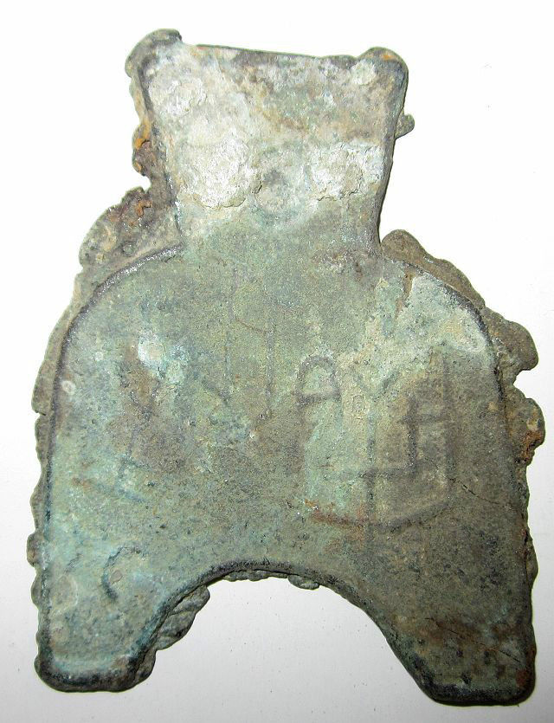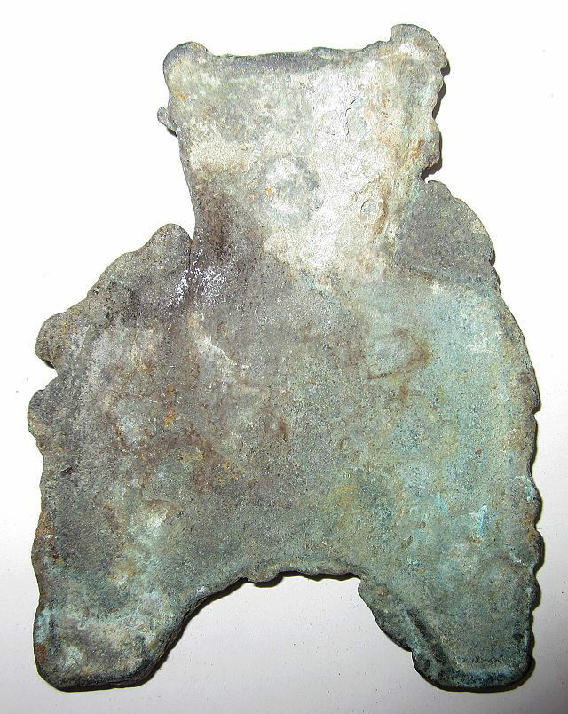

Example 2. Ān Yì Èr [two] Jīn, 安邑二釿, length 4.5CM/1.77Inches, width 3.3CM/1.30Inches.

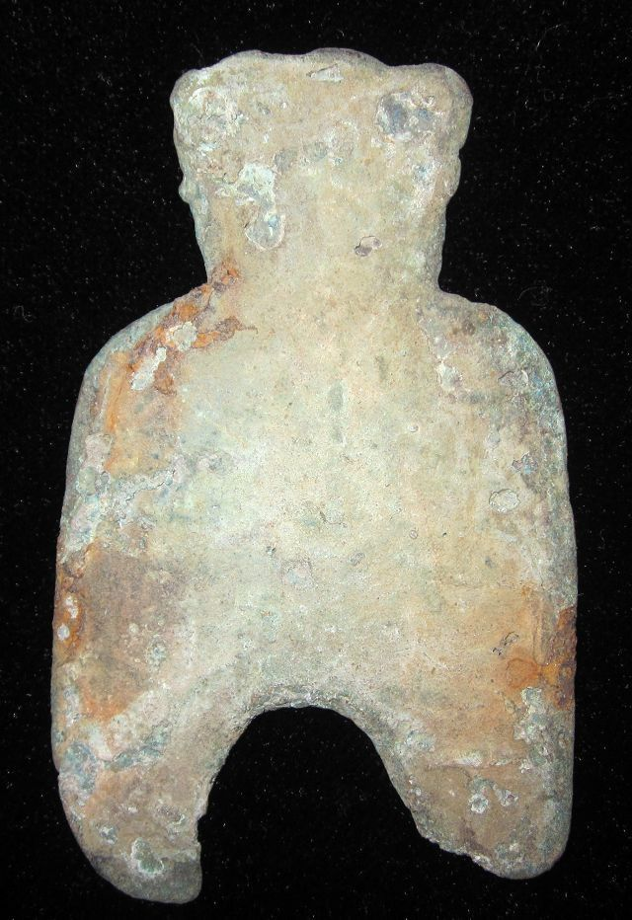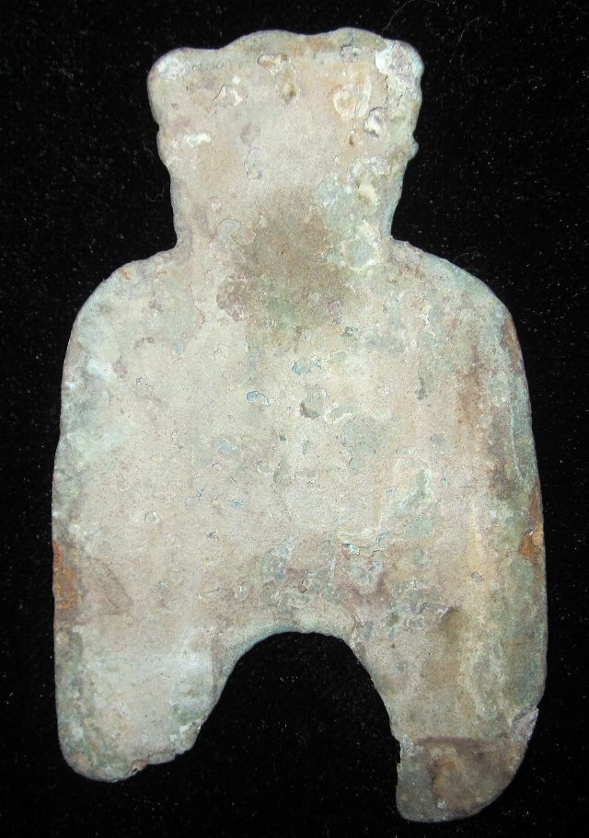

Type1. 弧足布Arched Foot Spade, Ān Yì Èr Jīn安邑二釿, Anyi Two Jin, Length 6.2CM/2.44Inches, Width 3.8CM/1.50Inches

Example 3. 京一釿/甫反一釿桥足布,Yi Yi Jin length, 4.2CM/1.65Inches, width 2.9CM/1.14Inches.

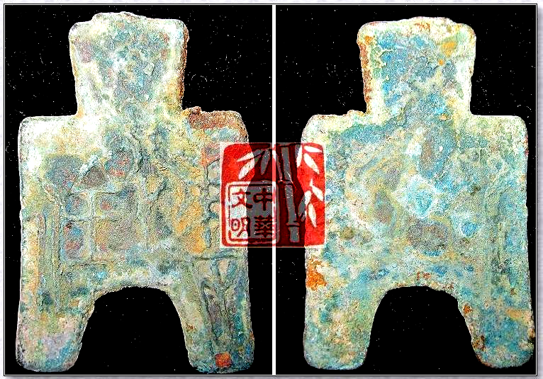

京一釿桥足布."京一釿"also called"甫反一釿"."京"Place of WEI,"一釿"Seals Weight.It was used in the WEI Nation,Warring States Period

Example 4. Liáng èr jīn, qiáo dāng bù, 梁二釿桥裆布length 6.5CM/2.60Inches , width 3.8CM/1.50Inches

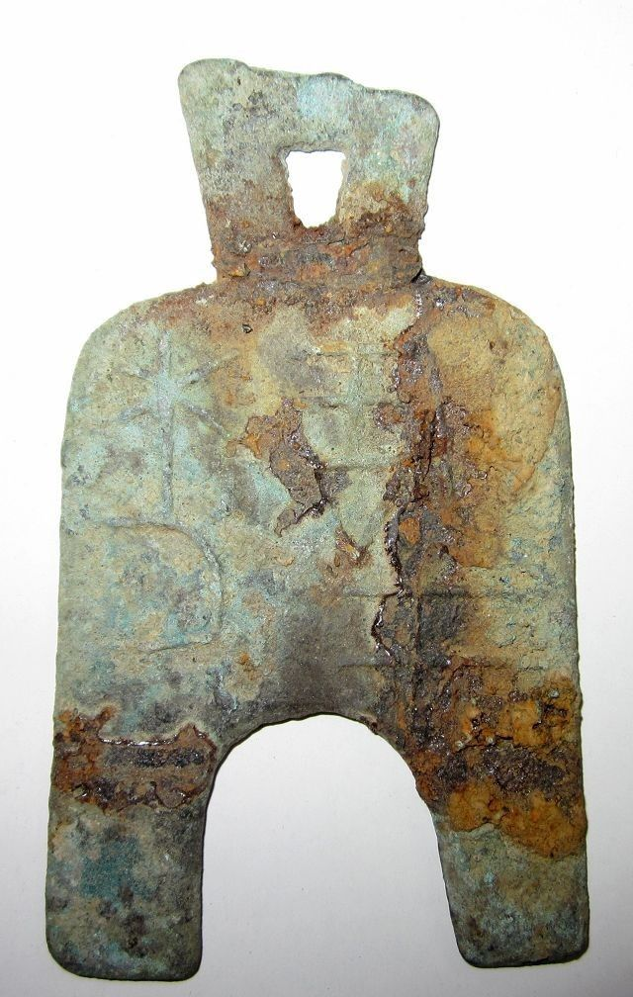 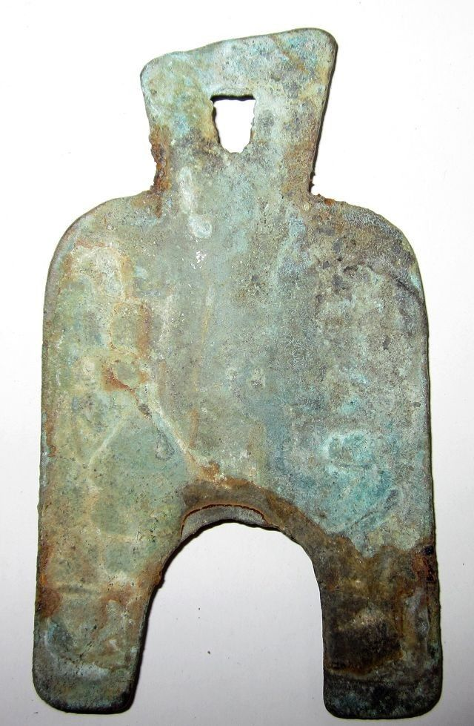

"梁二釿",Liang ErJin Spade-shape Coin.LIANG,Capital of WEi Nation,Now the KaiFeng Town,HeNan Province.JIN,Ancient metals weight,as well as currency.In the WarringStatesPeriod,all kingdoms regarded"JIN"as the basic unit.

l

